1. **What is regularization – reduce overfitting?**

Regularization is a technique which makes slight modifications to the learning algorithm such that the model generalizes better. This in turn improves the model’s performance on the unseen data as well.

1. **How does regularization help reduce overfitting?**

In machine learning, regularization penalizes the coefficients.

In deep learning, regularization penalizes the weight matrices of the nodes.

Assume that regularization coefficient is so high that some of the weight matrices are nearly equal to zero. This will result in a much simpler linear network and slight underfitting of the training data.

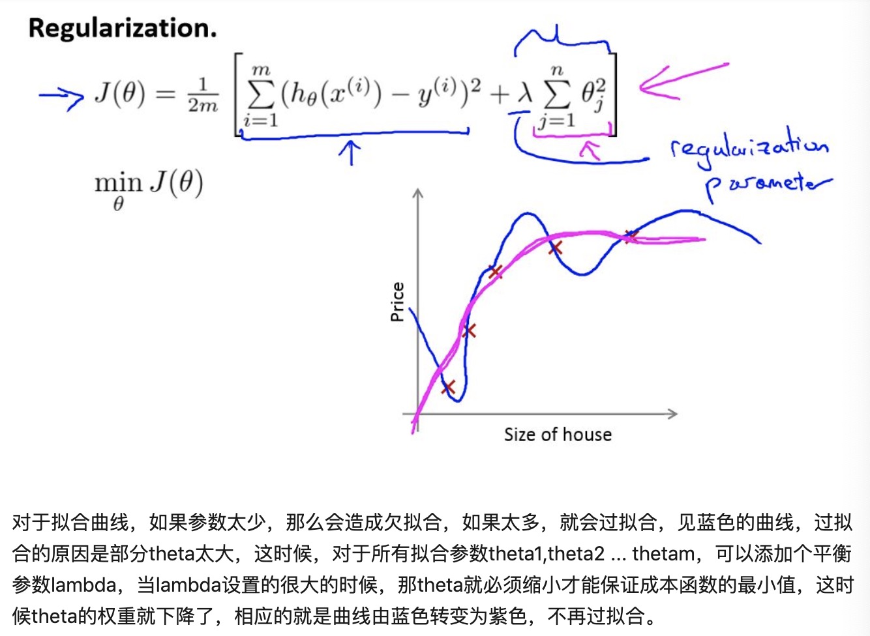

1. **Different regularization techniques in deep learning**
2. L1 & L2

Cost function = Loss (binary cross entropy) + Regularization term

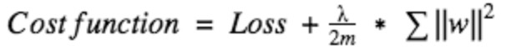



1. Dropout

At every iteration, it randomly selects some nodes and removes them along with all of their incoming and outgoing connections.

Ensemble models usually perform better than a single model as they capture more randomness. Similarly, dropout also performs better than a normal neural network model.

This probability of choosing how many nodes should be dropped is the hyperparameter of the dropout function. Dropout can be applied to both the hidden layers as well as the input layers.

1. Data augmentation

Increase the size of the training data: rotating the image, flipping, scaling, shifting…